

Open-Ended Lab Report

Terraform & Ansible – Frontend Backend High Availability Architecture

Student Name:
Maria Abdul Malik
Registration No:
2023-BSE-076
Course:
Cloud Computing
Lab Type:
Open Ended Lab

- Introduction
This report presents the complete implementation of an open-ended cloud computing lab using Terraform and Ansible.
The goal of this lab is to provision infrastructure automatically and configure a highly available frontend-backend web architecture.

- GitHub Repository Initialization
A dedicated GitHub repository was created to maintain version control and ensure clean separation of this lab from previous assignments

- GitHub Codespaces Environment Setup
GitHub Codespaces was used as the development environment to provide a consistent Linux- based setup.
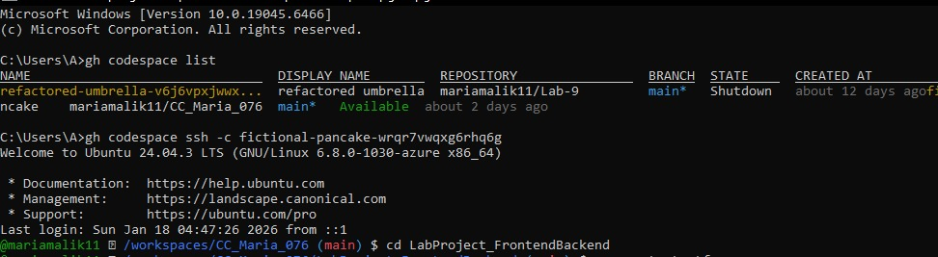

- Tool Installation & Verification
Required tools including Terraform, AWS CLI, Python, and Ansible were installed and verified before implementation.
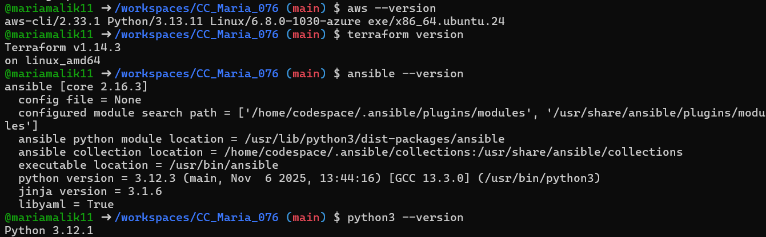
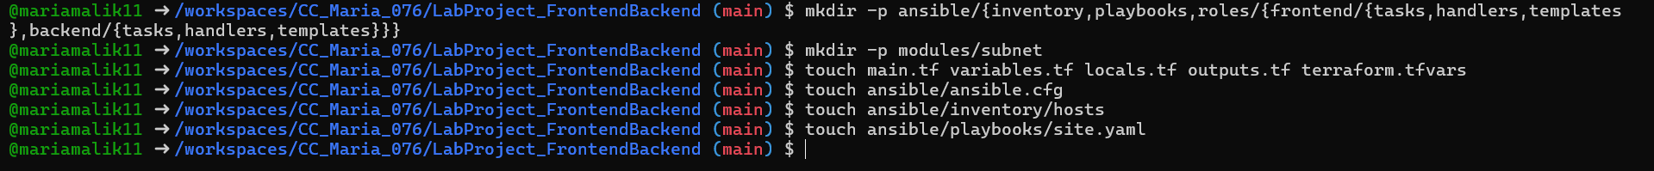
- Final Project Directory Structure

The final directory structure follows Terraform module-based design and Ansible role-based configuration.
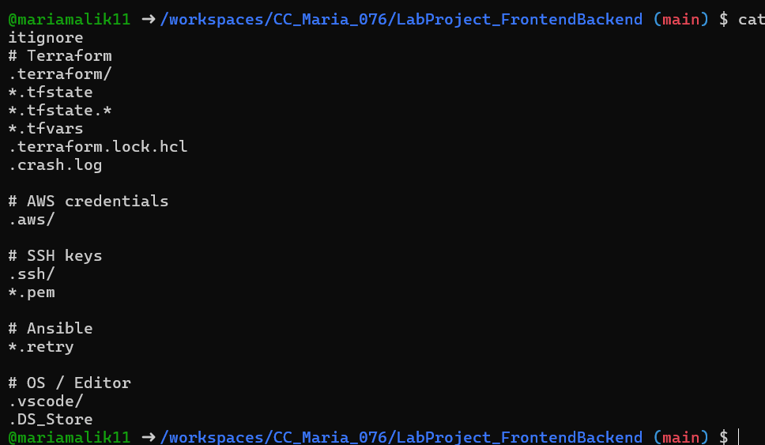
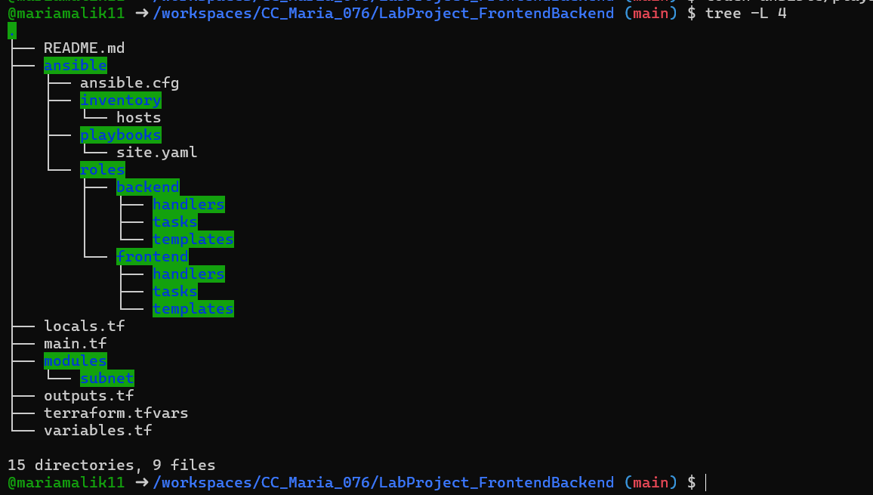

- Terraform Configuration
  - Provider & Variables Definition

Terraform provider configuration specifies the AWS region and credentials. Variables are used for reusability and flexibility.
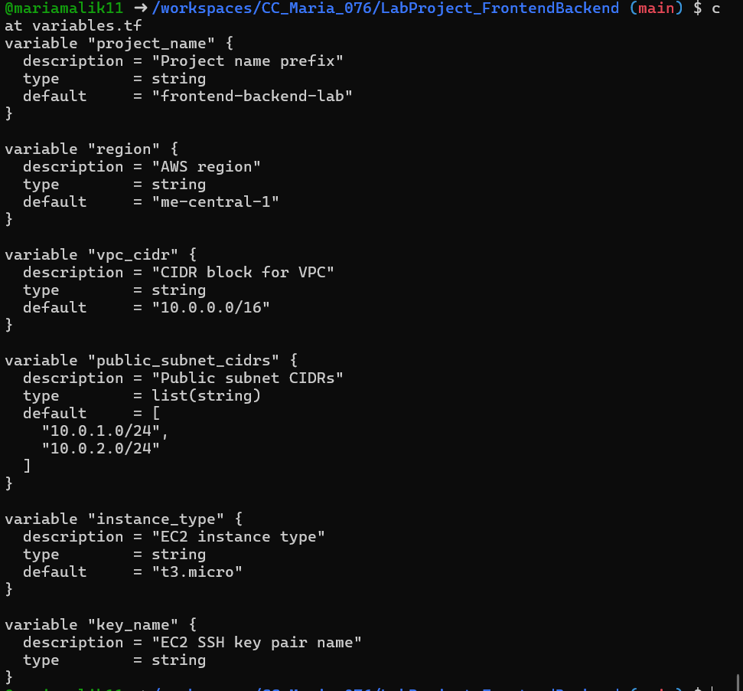
  - Local Values & IP Restriction
Local values dynamically retrieve the user's public IP to restrict SSH access securely.
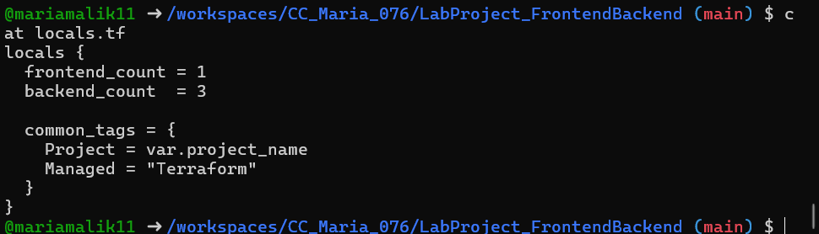

  - Networking (VPC, Subnet, Routing)
A VPC, public subnet, internet gateway, and route table are provisioned to allow internet access.
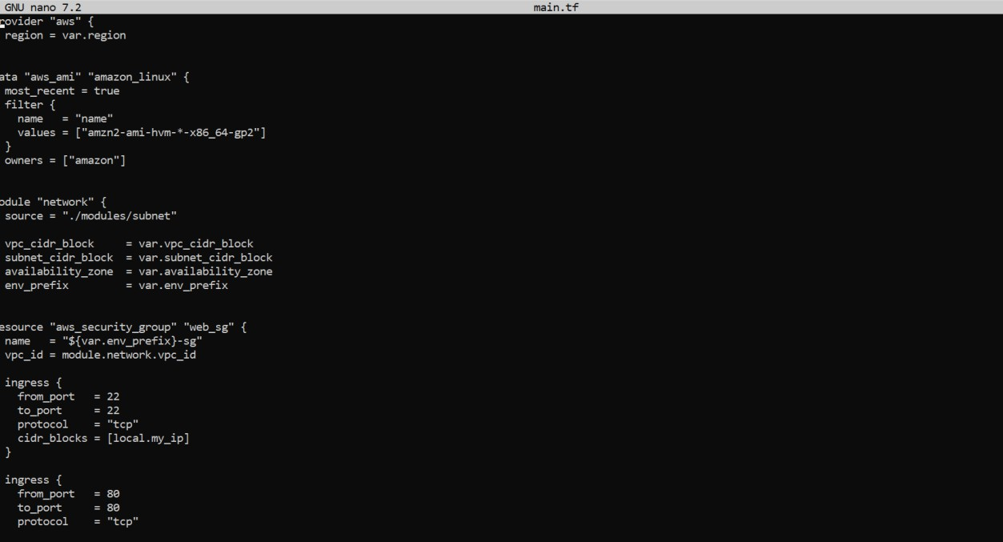

  - EC2 Frontend & Backend Provisioning
One frontend EC2 instance and tree backend EC2 instances are created using reusable Terraform modules.
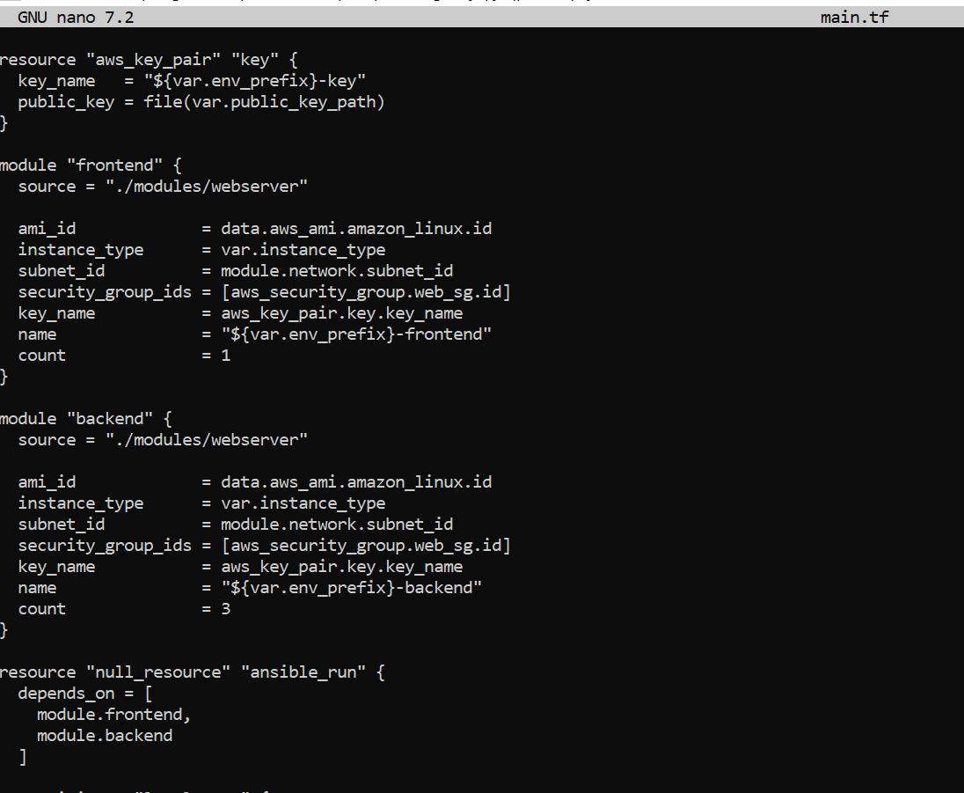

  - Terraform Outputs
Terraform outputs expose public and private IP addresses required for Ansible inventory and verification.
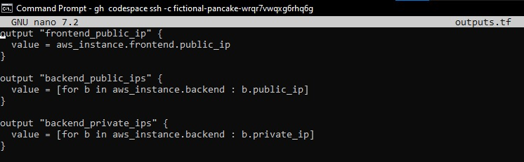

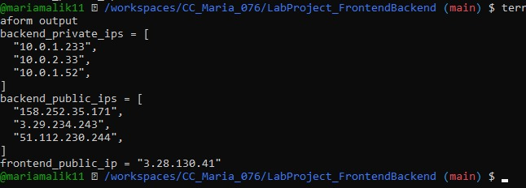

  - Terraform Modules Implementation
Terraform modules were used to improve code reusability, readability, and separation of concerns.
Instead of defining all resources in a single file, networking and compute logic were encapsulated into independent modules.

This approach aligns with infrastructure-as-code best practices and simplifies future scaling.
    - Subnet Module (Networking Layer)
The subnet module is responsible for provisioning the core networking components required for the project.
It creates the Virtual Private Cloud (VPC), public subnet, internet gateway, route table, and route table association.
This ensures that all EC2 instances are deployed in a properly configured public network with internet access

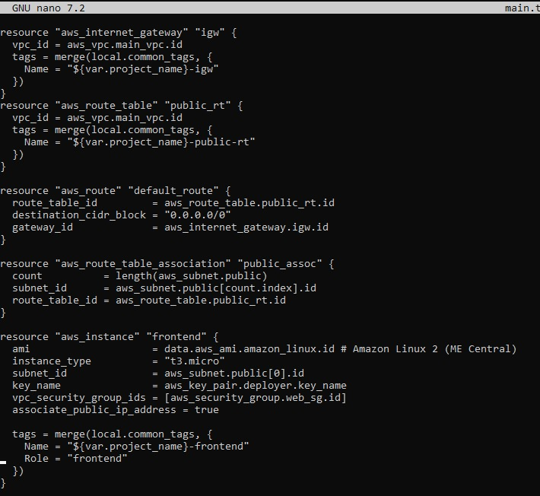

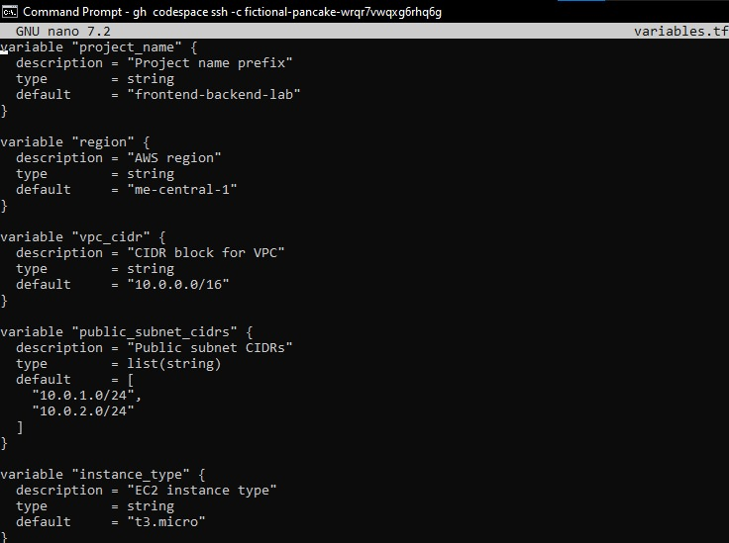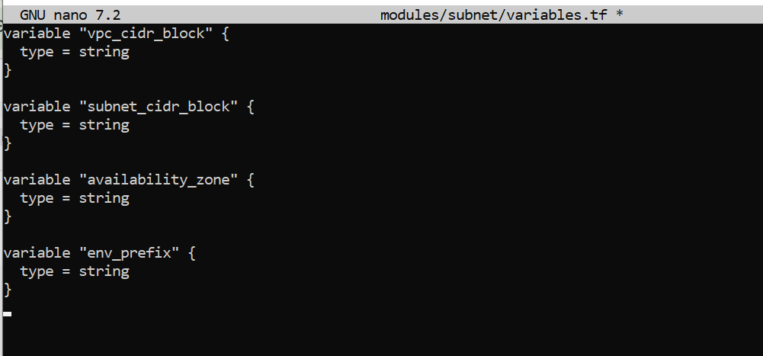
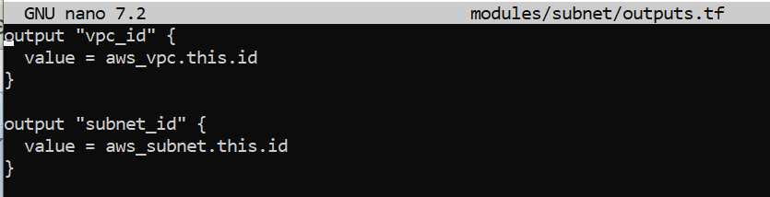

    - Webserver Module (EC2 Abstraction Layer)
The webserver module abstracts EC2 instance creation into a reusable component.
It is used to provision both frontend and backend instances by passing different parameters such as instance count and naming prefix.

This modular design avoids duplication and ensures consistent EC2 configuration.

- Ansible Configuration:

  - Ansible Configuration File
The ansible.cfg file disables host key checking and specifies Python interpreter settings.
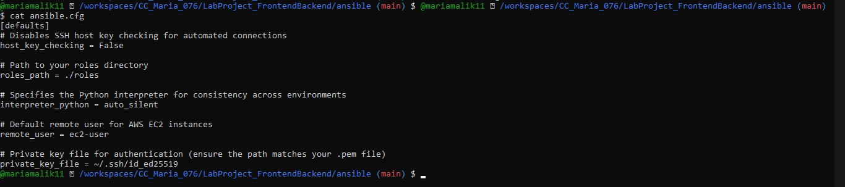

  - Inventory File
The inventory file groups frontend and backend servers to enable role-based execution.
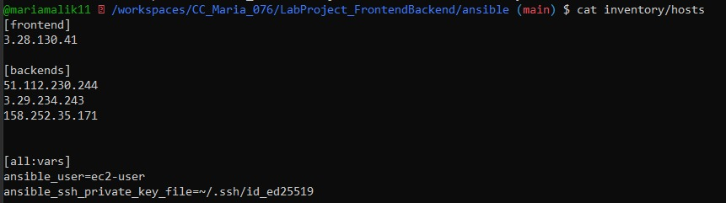

  - Backend Role (Apache HTTPD)
The backend role installs Apache HTTPD and deploys unique index pages on each backend server.
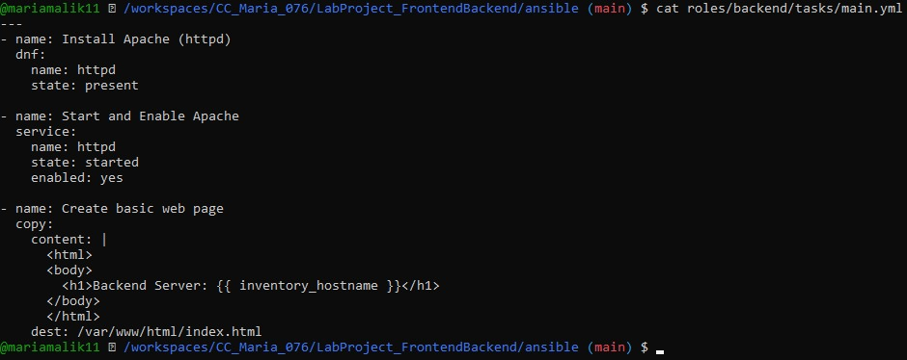

  - Frontend Role (Nginx Load Balancer)
The frontend role installs Nginx and configures it as a reverse proxy with two primary and one backup backend.
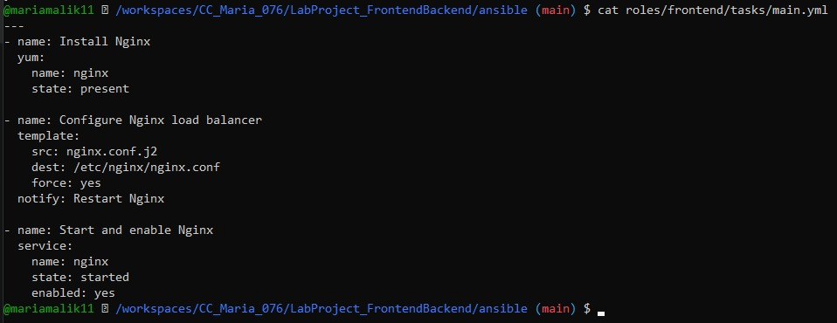

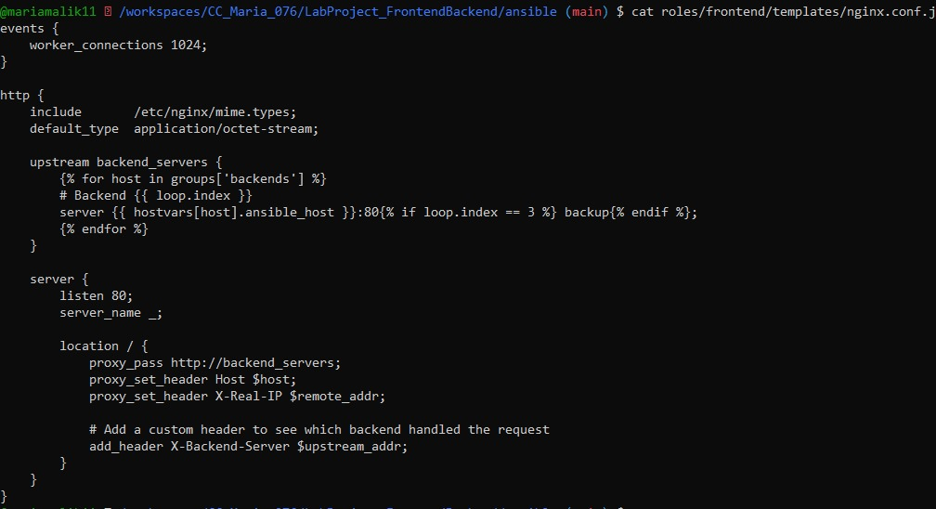

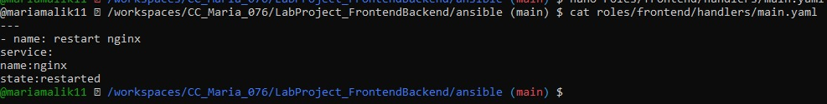

  - Main Playbook (site.yaml)
The main playbook applies backend configuration first, followed by frontend setup.
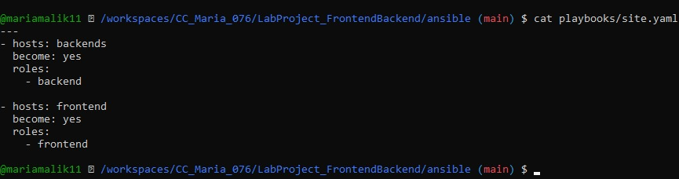

- Terraform Apply & Automation Execution
Terraform apply provisions all resources and automatically triggers Ansible using a null_resource.
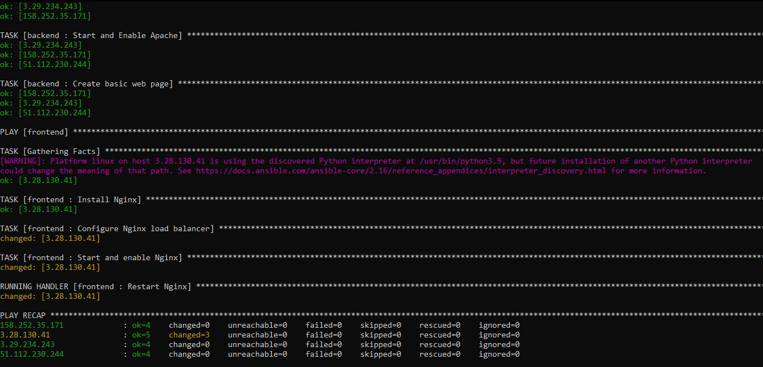

- Backend Server Verification

The following unlabeled screenshots show direct access to backend servers using their public IPs.


Backend Server

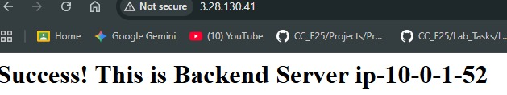
Backend Server

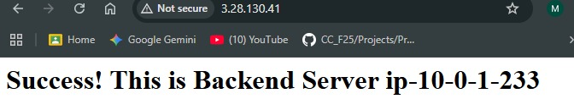

Backend Server

Frontend Load Balancer Verification

Frontend Response

Frontend Response

Load Balancing Behaviour Validation

Refresh-1

Refresh-2

Refresh-3

Refresh-4

Failover Testing (Backup Backend)

Backup Backend Response

Conclusion
This lab successfully demonstrates automated infrastructure provisioning and configuration management.
The architecture meets all requirements of high availability, modularity, and automation.

